Project Report Template
Title of Project: AI Powered Medicine Reminder
Name of the Innovator: Sneha Kademani
Start Date: 27-10-2025
End Date: 31-10-2025

Day 1: Empathise & Define
Step 1: Understanding the Need
- Which problem am I trying to solve?
I’m solving the problem many people, especially older adults or those who take several medicines, often forget to take their medicines on time or may take the wrong dose. This can cause health problems and slow recovery. Normal reminders like alarms or notes are not smart enough to handle changes in schedules. Also, family members or doctors may not always be there to remind patients. The AI-Powered Medicine Reminder helps solve this problem by giving smart and timely reminders, tracking the medicine schedule, and making sure people take their medicines correctly for better health.

- Who is affected by this problem?
- How did I find out about this? [Select whichever is applicable]
- Interviews
- Observation
- Online Research
- AI Tools
Step 2: What is the problem?
The problem in the AI-Powered Medicine Reminder is that many people forget to take their medicines on time or take the wrong dose. This often happens with old people or those who take many medicines daily. Forgetting medicines can cause health problems and slow recovery. Normal reminders like alarms or notes are not smart enough to check if the person has actually taken the medicine. So, there is a need for a smart system that reminds people on time and helps them take their medicines correctly.
Why is this problem important to solve?
This problem is important to solve because forgetting to take medicines can make a person’s health worse. It can slow recovery or cause serious problems, especially for old people or those with long-term illnesses. Taking the wrong dose or missing a dose can also make the treatment fail. By using an AI-powered medicine reminder, people can take their medicines on time, stay healthy, and avoid hospital visits.
Take-home task
Ask 2-3 people what they think about the project:
- An elderly user said the app was very helpful and easy to use, especially the voice reminders that reminded them to take medicines on time.
- A doctor appreciated the idea, saying it could help patients follow their prescriptions correctly and reduce missed doses.
- A caregiver mentioned that the tracking feature was useful to monitor whether their family members had taken their medicines, making it a reliable health support tool.

AI Tools you can use for Step 1 and 2:
AI Tools Used:
- Meta MGX
- Used as a no-code development tool to design and build the AI-Powered Medicine Reminder app.
- Helps in creating user-friendly interfaces, reminder scheduling systems, and notification workflows without coding.
- Ideal for building features like medicine tracking, user registration, and alert customization.
2. ChatGPT
- Used for idea generation, content creation, and chatbot conversation design for patient interaction.
- Helped in framing smart reminder messages, health tips, and voice-based responses for the app.
- Also useful for generating personalized reminder schedules and improving the overall user experience.
3. Chatbot References (Structure Design):
To design the AI virtual assistant, you can take reference from:
- Google Dialogflow – to understand intent detection, such as recognizing medicine names and reminder times.
- IBM Watson Assistant – to design structured Q&A for health-related queries and missed dose management.
- Microsoft Bot Framework – to manage user profiles, store medicine details, and handle conversation flow effectively.
Day 2: Ideate
Step 3: Brainstorming solutions
- List at least 5 different solutions (wild or realistic):
- AI-Powered Medicine Reminder App – A smart mobile app that reminds users to take their medicines on time using voice alerts, notifications, and personalized schedules.
- Smart Pill Box with AI Integration – A medicine box connected to AI that automatically alerts users when it’s time to take their medicines and tracks which tablets have been taken.
- Voice Assistant Reminder System – A voice-based reminder that uses AI to talk to patients, remind them about their medicines, and confirm if they’ve taken them.
- Family & Doctor Notification System – Sends automatic alerts to family members or doctors if the patient misses a dose or takes the wrong medicine.
- AI Health Monitoring Platform – An advanced system that not only reminds about medicines but also tracks health data like blood pressure or sugar levels and adjusts reminders accordingly.
- MediCare AI Platform – A complete digital platform combining AI reminders, smart pill tracking, voice alerts, and real-time health insights, built using tools like Meta MGX and ChatGPT to improve medicine management and patient care.
Step 4: My favourite solution:
My favourite solution is the AI-Powered Medicine Reminder because it helps people remember to take their medicines on time. Many people, especially older adults or busy ones, often forget their medicines, which can affect their health. This app gives reminders through messages or voice alerts and can also inform family members or doctors if a dose is missed. It can be made using tools like Meta MGX and ChatGPT to create a simple and easy-to-use system. This idea is helpful, smart, and can keep people healthy.
Step 5: Why am I choosing this solution?
I am choosing this solution because many people forget to take their medicines on time, which can harm their health. This app gives smart reminders and helps people take the right medicine at the right time. It is easy to use and very helpful, especially for old people and patients who take many medicines daily. It can also remind family members if someone misses a dose. This idea can keep people healthy and make their lives easier.
AI Tools you can use for Step 3-5:
AI Tools for Step 3–5
1. Meta MGX
- Used to design and build the AI-Powered Medicine Reminder app without coding.
- Helps create the user interface, reminder system, and notification workflows.
- Supports adding features like user registration, medicine tracking, and alert customization.
2. ChatGPT

- Helps brainstorm solutions and generate new ideas for medicine reminder features.

- Used to design chatbot conversations that remind users about their medicines.

- Assists in writing reminder messages, health tips, and user interaction content.

3. Web Development Tools (for design and flow
- HTML & CSS – Used to design and style the web pages of the medicine reminder system.

- JavaScript – Helps in adding interactive features such as setting and managing reminders.

- Firebase / MySQL – Used for storing user data, medicine schedules, and reminder logs securely.
4. AI Research Tools
- Google Scholar / Research AI – Used to study existing AI-based health reminder systems and find ways to improve them.

- AI Text & Summarization Tools – Helps summarize the best ideas, features, and approaches to present them clearly.
AI Tools you can use for the take-home task:
Canva AI/CoPilot AI/Meta AI: Used to design web layout images or mockups showing how the AI-Powered Medicine Reminder website will look. These tools help visualize the homepage, reminder dashboard, and notification screens in a creative way.

Day 3: Prototype & Test
Step 6: Prototype – Building my first version
What will my solution look like?
- Home Screen: Welcomes the user and asks for basic info like age, education, and location.
- AI-Powered Virtual Assistant: Chat interface where users can ask about careers, scholarships, and job opportunities.
- Skill Development Section: Short modules for English, aptitude, and soft skills with interactive exercises.
- Location-Based Recommendations: Map or list showing nearby colleges, training centers, and relevant job options.
- Profile Dashboard: Tracks the user’s progress, completed skill modules, and saved opportunities.
Design Style:
- Simple and user-friendly interface suitable for all age groups, especially elderly and rural users.
- Clear icons and minimal text to ensure easy understanding and navigation.

- Mobile-first design for convenient access on smartphones and tablets.

- Voice assistance integration for users who may struggle with typing or reading.

Prototype Tools:
- Built using Meta MGX, no coding required, with all features interactive and testable.
What AI tools will I need to build this?
AI Tools Needed to Build CareerPath
- Meta MGX

- A no-code platform used to design and deploy the app .

- Enables building interactive screens, reminder setup modules, and chatbot interfaces without coding.
- ChatGPT (or similar LLMs)
  - Used to create AI-based virtual assistance, helping users set reminders and answer basic medicine-related questions.
- Can generate personalized reminders and health tips based on user data (medicine type, time, age).
- AI Web design
  - Dialogflow can be added to the AI-Powered Medicine Reminder web app by creating a chatbot, enabling the Web Demo integration, and copying its iframe code into the app’s HTML file.
  - Once added, users can interact with the chatbot directly on the website to set and manage their medicine reminders easily.
- AI Recommendation Tools (Optional but useful)
  - Enables voice commands for setting reminders.
  - Provides audio alerts and spoken reminders to help elderly users.
- AI Notification & Tracking Tools (Firebase ML Kit / TensorFlow Lite)
  - Used to manage real-time notifications and analyze user adherence (missed doses or delays).

  - Helps the system learn and adjust reminders intelligently based on user behavior.

- AI Data Analysis Tools (Optional for insights)

  - Python AI libraries (Pandas, Scikit-learn) for analyzing user patterns.

  - Helps improve accuracy of reminder timing and user engagement over time.

What AI tools I finally selected to build this solution?
- Chat GPT
- Metamgx

< Build The Innovation>
<DASHBOAD OF THE TOOL>
https://mgx-8mjsk1gsp3.mgx.world/
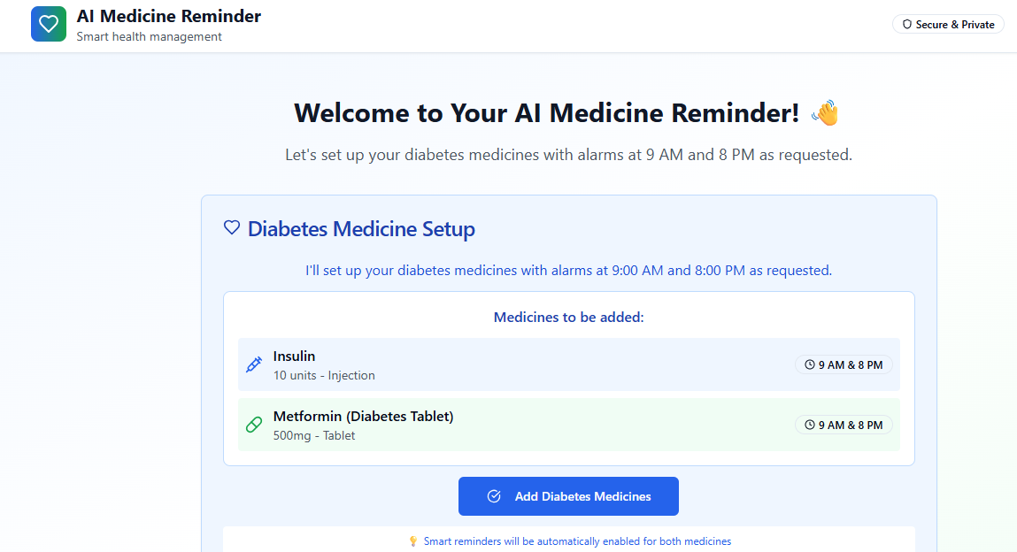

Internal Working of tool:
Profile Creation:
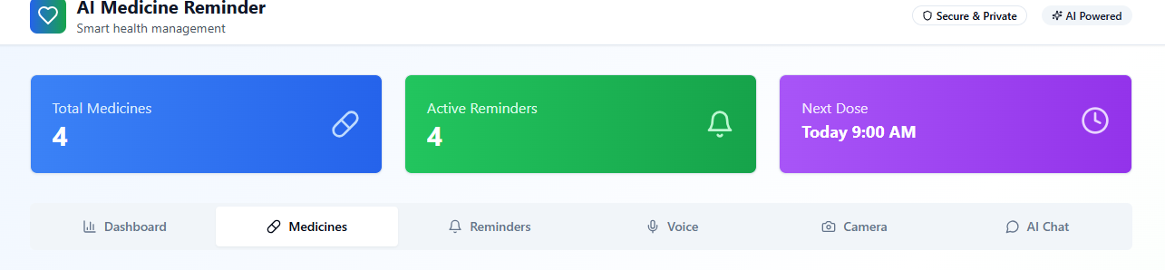

Tailoring recommendations using virtual assistant:
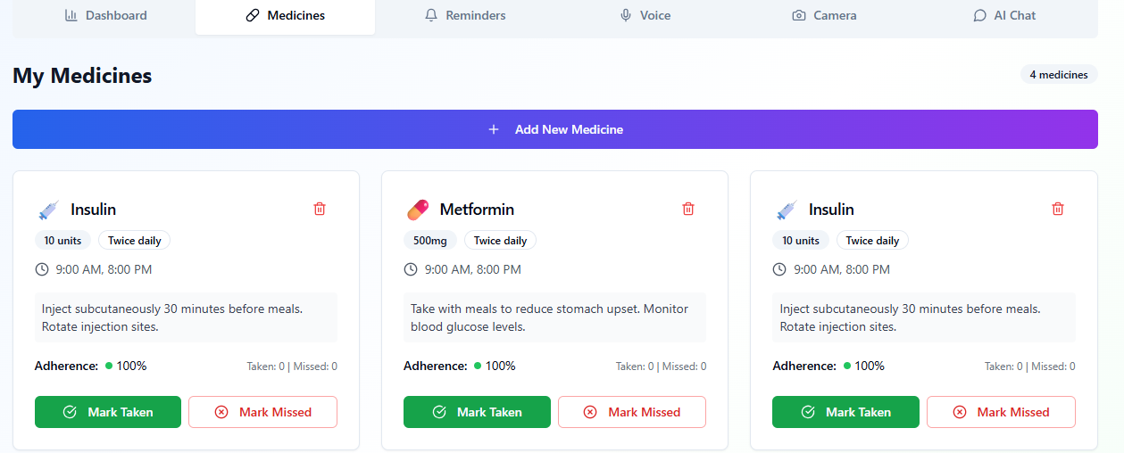

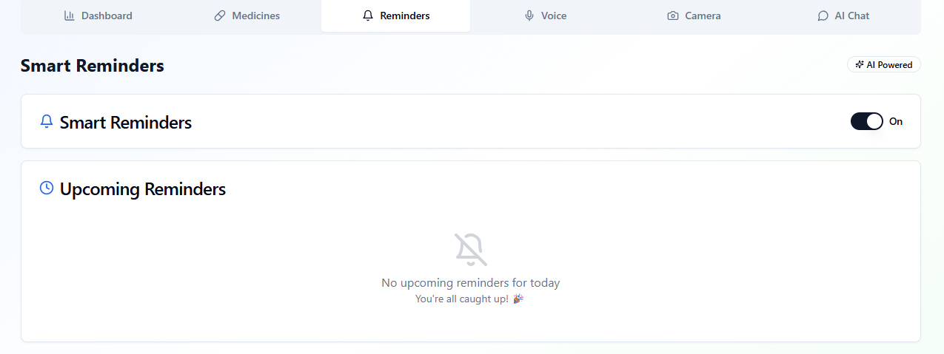

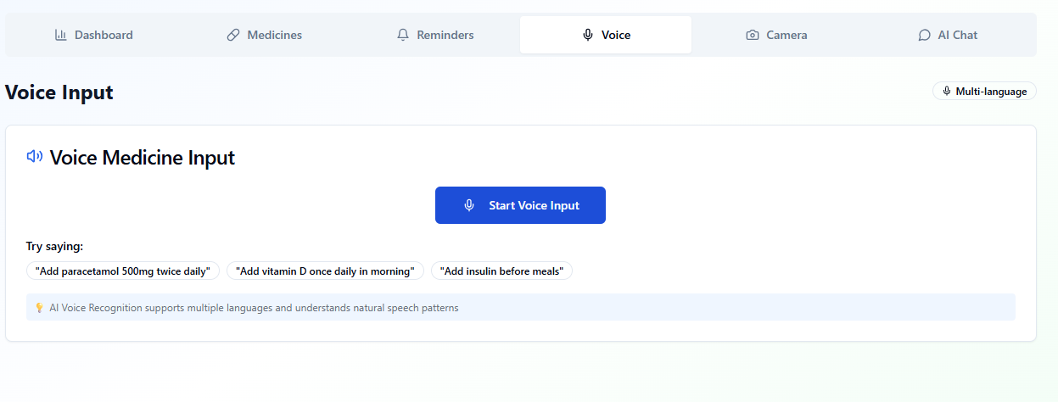

Recommendations based on Profile:
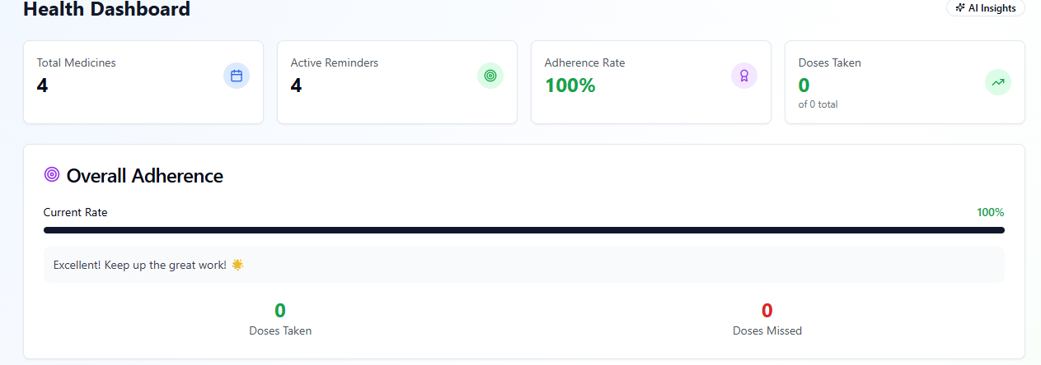
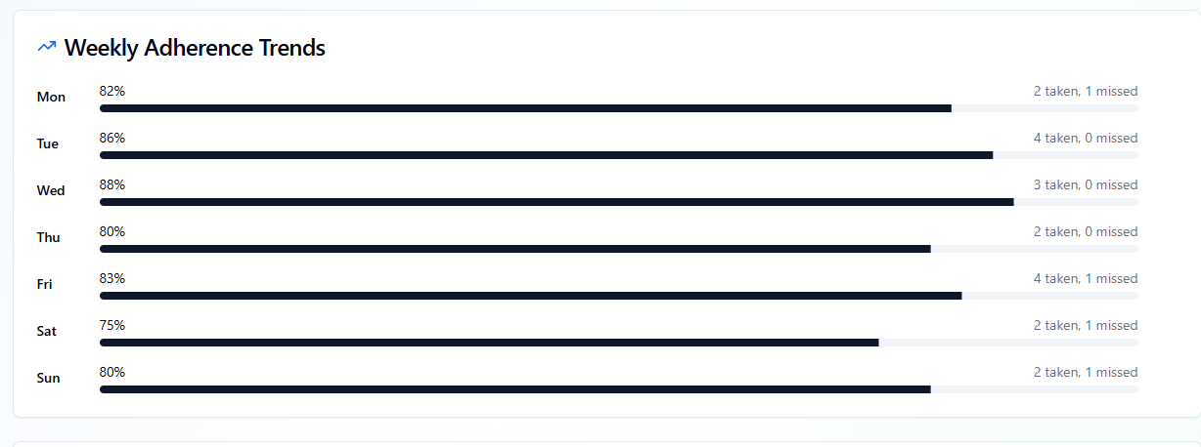

Step 7: Test – Getting Feedback
- Who did I share my solution with?
• Elderly people and patients – to check if the reminders and voice alerts are easy to understand and use.
• Doctors and pharmacists – to get feedback on the accuracy and usefulness of medicine schedules and alerts.
• Caregivers and family members – to see how well the app helps them manage reminders for their loved ones.
• Peers and mentors – for suggestions on improving the app’s design, chatbot responses, and overall usability.
I shared my CareerPath solution with:
What feedback did I receive?
Feedback: Pros and Cons
Pros (Positive Insights from Feedback):
- Users found the AI reminders and voice alerts very useful in helping them take medicines on time.

- The simple and clear interface was appreciated, especially by elderly users.

- Caregivers liked the feature that helps track missed doses and sends alerts for family members.

Cons (Areas to Improve Noted in Feedback):
- Some users reported that the voice reminder volume was too low or inconsistent on certain devices.

- The chatbot occasionally misunderstood commands or needed clearer instructions.

- The prototype lacked multilingual support, which made it difficult for some rural users to interact easily.

- Internet connectivity issues in rural areas affected real-time notifications and updates.

My Response for The Feedback:
The AI-Powered Medicine Reminder is an initial prototype developed using a no-code tool (Meta MGX). As it is an early version, some features like advanced voice control, multilingual support, and real-time health tracking are limited. To make the system fully functional, integration with health databases, pharmacy systems, and IoT-enabled devices (like smartwatches) would be needed he current limitations are due to the prototype environment, but the concept effectively demonstrates the usefulness, simplicity, and potential impact of AI in helping patients — especially the elderly — manage their medicines on time and improve their overall health routine.
What Works Well doesn’t require subscriptions and can be updated or modified anytime.
- Free and Easy to Update: The app doesn’t require subscriptions and can be updated or modified anytime to add new medicines or features.
- No-Code Development: Built using a no-code platform, allowing easy creation and maintenance without programming knowledge — ideal for students or beginners.

- AI-Based Assistance: The AI assistant helps users set medicine reminders, track doses, and provides simple health tips based on their schedule.

- Voice and Notification Alerts: Users receive clear voice reminders and notifications to ensure medicines are taken on time.

- Health Tracking: The system keeps a record of taken and missed doses, helping users or caregivers monitor regularity.

- Simple and User-Friendly Design: The interface is mobile-friendly, intuitive, and especially suitable for elderly users or those in rural areas.

👍 What works well:

Lifetime Access: Unlike other tools, Career Path built on Meta MGX
🔧 What needs improvement:

- Web Responses:The AI assistant sometimes repeats answers or doesn’t fully understand certain medicine-related commands, which can confuse users.

- Interactive Features: Some features, like advanced tracking and voice control, are limited in the current prototype and need full integration.

- Health Data Integration: The app currently lacks connection with pharmacies or health apps to automatically update medicine schedules.

- Collaborations Needed: To expand functionality, partnerships with healthcare providers, pharmacies, and IoT device makers are required.

- User Experience Enhancements: Improvements in voice clarity, reminder customization, and interface visuals can make the app more user-friendly and engaging.

AI Tools you can use for Step 6-7:
ChatGPT/Perplexity AI/Claude AI/Canva AI/Chatling AI/Figma AI/Metamgx/Gamma AI: You can use these tools to build solutions/models or mock-up dummy prototypes
Day 4: Showcase
Step 8: Presenting my Innovation:
I am presenting the AI-Powered Medicine Reminder System, a smart healthcare assistant designed to help users — especially elderly people and patients — take their medicines on time. It features:
- An AI-powered virtual assistant that helps users set medicine reminders, track doses, and provides basic health tips.
- Voice and notification alerts to remind users about their medicine schedules at the right time.
- Health tracking features that record taken and missed doses for better monitoring.
- A simple, mobile-friendly interface built using Meta MGX, offering lifetime access and easy updates without coding.
Impact:
The AI-Powered Medicine Reminder System promotes timely medication, supports elderly and rural users, reduces missed doses, and encourages healthier, more independent living through the power of AI.

<SHOWCASE YOUR INNOVATION TO YOUR PEERS>
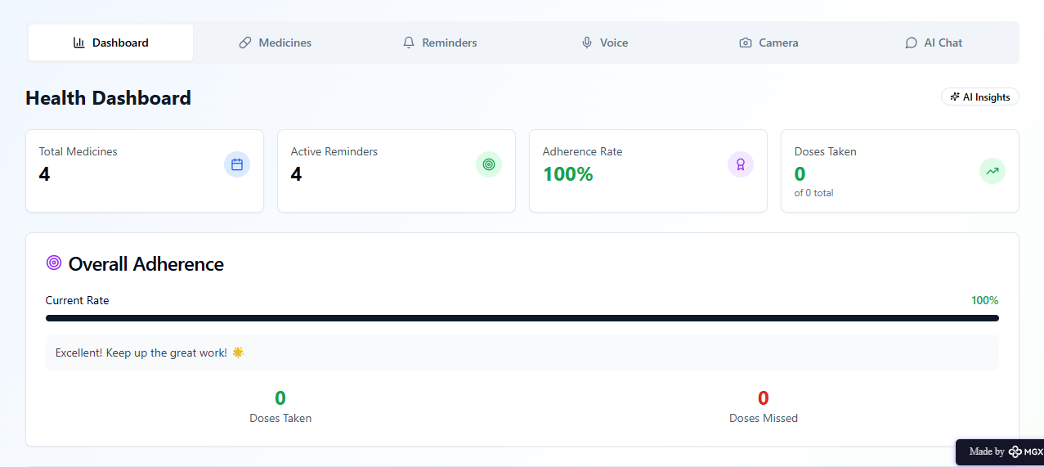
Step 9: Reflections
- What did I enjoy the most during this project-based learning activity?
I enjoyed building the AI-Powered Medicine Reminder System using a no-code tool and watching my idea come to life as a real, interactive application. It was exciting to design the AI assistant, set up voice and notification reminders, and create a simple interface that could truly help elderly people and patients manage their medicines easily and improve their daily health routine.
- What was my biggest challenge during this project-based learning activity
My biggest challenge was integrating all the AI features smoothly in the prototype using a no-code tool, especially making the voice reminders, chatbot assistance, and medicine tracking system work together effectively. It was also challenging to ensure that the app remained simple, user-friendly, and accessible for elderly users while working within the limitations of the prototype environment.
Take-home task
https://github.com/kademanisneha9-blip/AI-PWERED-MEDICINE-REMINDER
AI Tools you can use for Step 8:
Canva AI: You can use this to design your pitch document. Download your pitch document as a PDF file and upload on GitHub

